

Cybersecurity Threats in Healthcare

By: Sajid Rahim, CSIT Jalozai

ABSTRACT Insider attacks are becoming increasingly detrimental and frequent, affecting critical infras-tructure at a massive scale. Recent attacks such as the U.K. National Health Service WannaCry ransomware attack which partly depends on internal users for initial infection highlight the increasing role of the malicious insiders in cyber-attack campaigns. The objective of this research is to ascertain the existing technological capability to mitigate insider threats within computer security systems by way of a mixed-method systematic review. Evidence was acquired from major sources of mainstream and grey literature by analyzing about 300 000 papers. Crude aggregated results were analyzed across the literature, and the results were TPR 0:75, FPR 0:32, 0:24 and 0:36, respectively, and ² 0:06 and 0:13, respectively. In totality, the literature evidence suggests that there is high heterogeneity across crude data indicating that the effectiveness of security measures varies signi cantly. No solution is able to totally mitigate an insider threat. Themes when set against that data suggest that most, if not all, security measures require breaches to occur before an analysis of malicious activity can prevent it in future through recall. Such a reactive approach is not effective to protect our critical infrastructure including our healthcare systems. Consequently, there is a major theoretical shortfall in current cyber defence architecture.

INDEX TERMS Critical infrastructure security, personal data safety, healthcare, data breach, insider threat, meta-data, sabotage, systematic review, thematic analysis, unprivileged, untrusted, zero trust.

I. INTRODUCTION

There are more data breaches reported now every year than one could care to count [1]. A signi cant percentage of these breaches were experienced in critical national infrastruc-ture, which includes public health sector, power, communi-cations, transportation, oil and gas, and nancial institutions. In wartime, these are often designated as preferred mili-tary targets, which when compromised, will cause public panic, disconnection of communications and disruption to transportation. Today, the world is in the infancy phase of electronic warfare. Cyber attacks offer the ability to destroy or disrupt infrastructure targets remotely and anony-mously, in very stealthy ways. In the healthcare sector for example, many corporations are interlinked with the govern-ment, and hence, data breaches can have a destructive impact on an entire nation. Citizens con dence and the economy will be affected by data compromise as many companies that

operate public services also have other government contracts and interactions.

One of the major contributing factors to the increasing prevalence of ‘‘data disasters’’ is the inability to resolve the age-old problem of what happens when either (i) a person trusted to use a computer system betrays its owner to commit cybercrimes, (ii) a hacker casually makes his way past a re-wall and sits behind it for some time committing cybercrimes to the almost certain ignorance of the system administrators. It is suggested by some commentators such as [2] that security often works like an onion with layers upon layers of security zones. It suggests that all it takes is for an inside threat to slip between security zones and they will become virtually undetectable, particularly if novel threats.

Catastrophic data breaches are becoming the story of the day increasingly often. Most recently, as at the date of pub-lication, was the Equifax data breach in which potentially

VOLUME 6, 2018 | This work is licensed under a Creative Commons Attribution 3.0 License. For more information, see http://creativecommons.org/licenses/by/3.0/ | 25167


S. Walker-Roberts et al.: Systematic Review of the Availability and Efficacy of Countermeasures to Internal Threats

information on 143 million US citizens and 44 million British citizens was stolen by hackers in May-July 2017. Before that was the NHS cyberattack. There is the Ashley Madison Breach, the TalkTalk breach, the OPM breach, the CIA/NSA ‘‘hacking tool’’ leaks, the Yahoo data breach, the Sony data breach, the MySpace data breach and so on these organi-sations are not small players. These particular breaches have been apparently focussed on theft, but it would be right to question what would happen if instead they chose to sabotage or intentionally compromise a system or infrastructure in such a way as to seriously endanger life. This is increasingly relevant due to the role of cyberwarfare in statecraft.

Where it concerns healthcare speci cally, cybersecurity has the potential to threaten life very easily. Most NHS trusts in England and Wales have application services presented as web applications with various backing stores, the most common being static le stores and databases. These are served at desktops, mobile devices and on ubiquitous devices (including medical equipment such as patient monitors). If these services become compromised or are successfully attacked, then critical internal infrastructure services such as access to laboratory results, radiography and real-time patient physiological information will be unavailable. Medi-cal devices themselves can also be compromised, for example by DDoS on the wi networks which they use to commu-nicate with central monitoring stations. There is the addi-tional danger of data theft owing to the exchange of data across so many devices. The Verizon VCDB dataset shows that over 1200 serious attacks were directed speci cally towards healthcare infrastructure, which it identi es to be an increasing trend [3]. The recent NHS WannaCry attack is said by the National Audit Of ce to be the largest of its kind affecting a healthcare organisation in recorded history [4]. Embarrassingly, that report con rms that the NHS was not even a speci c target, but had failed to comply with policy directions for the improvement of infrastructure and was still widely using Windows XP that was at that time no longer supported by Microsoft.

In a critical infrastructure context, the problem was that policy was clearly disengaged from front-line practice in the NHS [4]. One industrial research report illustrates that on more than 51% of occasions, the blame for a cybersecurity breach is negligent internal [5]. Similarly, another report pro-jected that cybersecurity breaches were likely to cost health-care providers potentially ‘‘$300 billion’’ in the future [6]. The most reported cause of cybersecurity breaches is neg-ligence, therefore, it has to be questioned how this can be mitigated in practice. The National Audit Of ce identi-ed, that had the WannaCry ransomware not been disrupted by coincidence when a cybersecurity analyst discovered a ‘‘phone home’’ mechanism by accident, then it is likely that signi cantly more devastation would have occurred [4]. Therefore, this scoping exercise must be conducted to under-stand the threat of internally-directed attacks in critical infras-tructure such as in a healthcare setting like the NHS.

25168

In the present threat climate, it is reasonable to question whether security breaches must be as a result of something more than a failure to follow best practices and why exist-ing measures are ineffective. This mixed-method systematic review aims to investigate precisely that issue. A systematic review is an evidence-based literature review which goes beyond an ordinary review in rigorously assessing the qual-ity of the literature using methods approved by the body of academic opinion. This approach was used because of the number of dogmatic practices in cybersecurity and little encompassing research which challenges that position as being unsatisfactory, it aims to be a fresh alternative to the typical survey of computer science literature which provides thorough critical analysis.

We have chosen the systematic review style to address the shortage of knowledge about effects of insider threats against security of critical infrastructure, particularly in the healthcare sector, because it is a highly approved academic scoping method within public health in the United Kingdom and abroad. This is owed mostly to the fact that systematic reviews are impartial and concise with adherence to a speci c protocol. It amounts to an excellent tool for ‘‘proving’’ the state of the art as opposed to a subjective (potentially biased) literature summary in a survey context. The closest work to ours is the systematic literature review of insider threats offered by [7]. However, they have utilised a challenge metric which compounds potential differences affecting per-formance and effectiveness metrics for speci ed algorithms in Intrusion Detection and Prevention Systems (IDPS), thus harmonising data to t a meta-analysis which would other-wise be inappropriate (this also introduces a substantial risk of bias). As a result, there is an opportunity to conduct an updated systematic review more relevant to internal threats. The objective of this systematic review is to ascertain the state of the art in computer security where the ability to mitigate insider threats within computer security systems is concerned in particular, especially as it relates to critical public infrastructure such as in the healthcare setting. It aims to extract data from the literature using mixed qualitative and quantitative methods. The quantitative data extracted will be explored in the context of qualitative themes in narrative synthesis lending itself to the mixed method extraction of data from studies. To achieve this aim, the following research questions will be answered:

- To what extent are current technologies able to mitigate insider threats which abuse privilege?

- What is the current research trend for insider threat mitigation?

- What are the most effective methods of mitigating insider threats?

This systematic review is only concerned with the effec-tiveness of existing security measures to mitigate inside threats, the present research trend and the extent current tech-nology is able to mitigate internal threats within a computer security system.

VOLUME 6, 2018

S. Walker-Roberts et al.: Systematic Review of the Availability and Efficacy of Countermeasures to Internal Threats

The rest of this paper is organised as follows: Section II presents the systematic review methodology. Section III presents the systematic review results. Section IV discusses the review results. Section V gives recommendation for practice and associated theoretical implications. Section VI concludes the paper and gives future research directions.

II. METHODOLOGY

The following databases were searched: ACM Digital Library, BASE (GreyLiterature), Collection of Computer Sci-ence Bibliographies, DANS (Grey Literature), dblp (Grey Literature), IEEE Xplore, JStor, OpenGrey (Grey Literature), ScienceDirect, Springer, Wiley, Zetoc (Grey Literature). There were two reviewers. The search returned 2577 results, of which 474 were duplicates, leaving the actual number of results at 2103. The search terms used were as follows: ((com-puter AND (misuse OR abuse)) OR (inside* NEAR threat), ((computer AND (misuse OR abuse)) OR (inside* NEAR threat)) AND (unprivileged OR trust OR privi-lege), (unprivileged). The literature search was intentionally cast wide to consider as many results as possible in con-nection with the research questions posed in this systematic review.

Grey literature was searched to avoid publication bias. All results were blinded as to publication status during the sifting phase. The review protocol is summarised in Figure 1 and a statistical summary of the results returned for each database search are included at Table 1.

TABLE 1. Results summary.
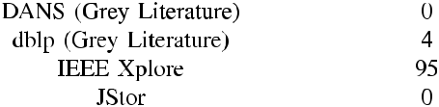


A. SELECTION OF STUDIES

The sifting phase is where each individual piece of literature was assessed against the inclusion and exclusion criteria and a decision made as to whether it should be excluded or not. The sifting process was divided into following six phases.

In the rst phase, search results were ltered according to the inclusion and exclusion criteria, speci cally the date and the academic eld concerned. In this case, studies were selected from the past 9 years in the eld of computing. The reason studies were not selected prior to 9 years ago is

VOLUME 6, 2018

because of the rapidly developing state of the literature in that time which casts the relevance of earlier studies into doubt. More than 300,000 results were excluded at this stage.

In the second phase, all results were sifted based on appar-ent relevance to the research questions by title and abstract alone. 1195 results were excluded.

In the third phase, the remaining results were sifted on speci city by way of full reading. The full text article had to relate closely enough to the research questions posed in this systematic review. 720 results were excluded at that point.

In the fourth phase, all results were checked in detail for the presence of suf cient data which was appropriate in context to the research question posed (‘‘effectiveness’’). Many results were excluded because they measured only computing performance of a purported novel algorithm, not effectiveness. Thus, 96 results were excluded at this point.

In the fth stage, all results were checked for quality using standardised testing tools for quantitative and quali-tative research (see III-A). The results were further scored against set quality criteria within the protocol of the system-atic review. A total of 22 results were excluded at this stage as having not met the minimum criteria of quality.

A total of 70 studies remained to be considered for inclusion by way of full critical analysis. Of the available 70 studies, 18 were included and the rest (52) were discarded either because they scored less than R4 for relevancy or had higher than B1 for risk of bias. The remaining 18 were fully analysed. None of the 18 remaining results were from grey literature sources. Though it was within the criteria that studies should have a high impact, some borderline studies were included to avoid bias despite being low impact. A full result set can be found in [8].

The assessment process was stringent to ensure that only the highest quality studies with solid ndings were consid-ered for mixed-method synthesis due to the risk that detail could otherwise be abstracted by the methodology or a poor complementary synthesis. Borderline studies were excluded which had relevance scores of R3 or bias scores of B2. This was to avoid any potential risk of bias within the data extraction and synthesis. Borderline cases which had low impact were still considered as a mitigation against the risk of publication bias.

B. QUALITY ASSESSMENT

Quality for the research studies was broadly assessed in four ways. Qualitative studies were critically appraised using the CASP tool [9] for qualitative research, which is a well-established method of qualitative critical appraisal. Quan-titative studies were assessed using the SURE [10] critical appraisal tool which is a generic quantitative research assess-ment tool well-suited to the eld of computer science due to heterogeneity of methodologies within studies. Any grey literature was assessed using the AACODS critical appraisal tool [11]. Following critical appraisal, studies were then judged against the quality criteria of the review itself as set down in the protocol (see Appendix).

25169

S. Walker-Roberts et al.: Systematic Review of the Availability and Efficacy of Countermeasures to Internal Threats

C. DATA EXTRACTION

This is a mixed method systematic review undertaking Joanna Briggs Institute (JBI) approach [12]. This approach provides an evidence-based methodology for combining the results of qualitative and quantitative research. In this systematic review, included studies were analysed in both a quantitative and qualitative manner and so this is favourable. There were two reasons for this: (i) there were mixed qualitative and quantitative studies, though the majority were quantitative

- more data existed than the quantitative data provided in the studies alone.

The approach taken to analysing the quantitative and qual-itative data contained in the studies was to take a two stage process. In the rst stage, results and discussion were anal-ysed for key ndings and moments of importance to the objectives of those studies. These were converted to textual descriptions which were then further thematically analysed blinded as to the author or article title. The textual descrip-tions were coded and then themes were extracted from the codes emerging from the textual descriptions.

Then, from extracted quantitative data, common measures of results were identi ed and the gures extracted for fur-ther statistical analysis. Meta-analysis was planned but did not proceed because study methodology and sample sizes, along with factors affecting results, were too heterogeneous to safely perform a meta-analysis. Instead, the result measures were aggregated using a crude grand mean for True Positive Rate (TPR) and False Positive Rate (FPR) for those studies that provided those values.

  - RESULTS

A. EXTRACTED QUALITATIVE DATA

As described in Section II, all research papers were explored for moments of importance using the phenomenological approach of thematic analysis. Though the majority of the studies were not themselves qualitative, the JBI approach of textually describing key moments in the quantitative studies provided signi cant qualitative data which could then be used for thematic analysis. The textual descriptions were coded and then key themes extracted from recurring and similar codes. The textual descriptions and full thematic analysis can be viewed in [8]

A frequency chart of codes is provided in Fig. 2 and a statistical breakdown of the emergent themes in the thematic analysis in Table 2. It is apparent that the most com-mon codes are: anomaly detection (8), comparison of user behaviour (8), machine learning (6), behaviour pro ling (11), context dependent (5), low accuracy (4), malicious insider undeterred (4), algorithm optimisation (4) and improvement of algorithm (5).

The most common themes are: anomaly detection (11.5%), context dependence (14.9%), pro ling (21.8%), accu-racy (10.3%), scalability (13.8%), improvement of algo-rithm (10.3%).

The accuracy of the analysis is con rmed by the known fact that IDPS are the predominant mainstream utility for

25170

FIGURE 1. PRISMA flow diagram.
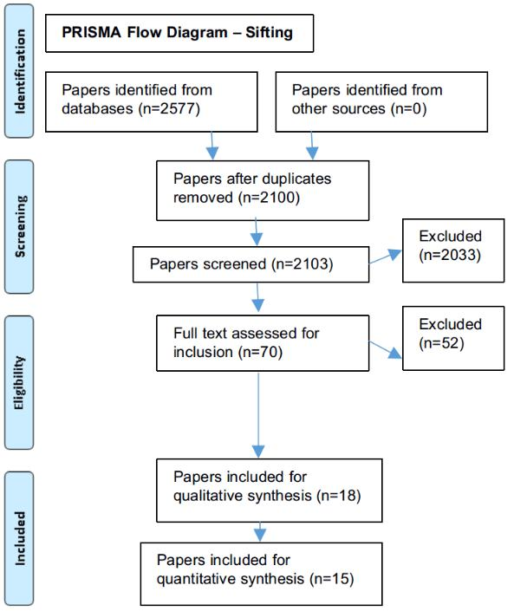

TABLE 2. Breakdown of theme occurrence.
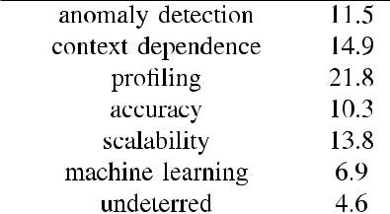


mitigating insider threats. Only rst order themes were derived as these appeared suf cient in quantity and quality to address the research problems. Had the rst order themes been subjected to second order thematic analysis, the result-ing themes would have been too inclusive.

B. EXTRACTED QUANTITATIVE DATA

All studies had result data, sample data and methodology extracted and placed onto a spreadsheet as in [8]. That data was then analysed for common measures. It is appar-ent from the spreadsheet used in the systematic review that 12 of 18 articles had a common measure of True Positive Rate (TPR), whilst 7 of 18 articles had a common measure of False-Positive Rate (FPR).

It was noted from the results that a common way of assess-ing TPR and FPR together is by constructing a Receiver Oper-ating Characteristic (ROC) curve in which a given ROC curve

VOLUME 6, 2018

S. Walker-Roberts et al.: Systematic Review of the Availability and Efficacy of Countermeasures to Internal Threats
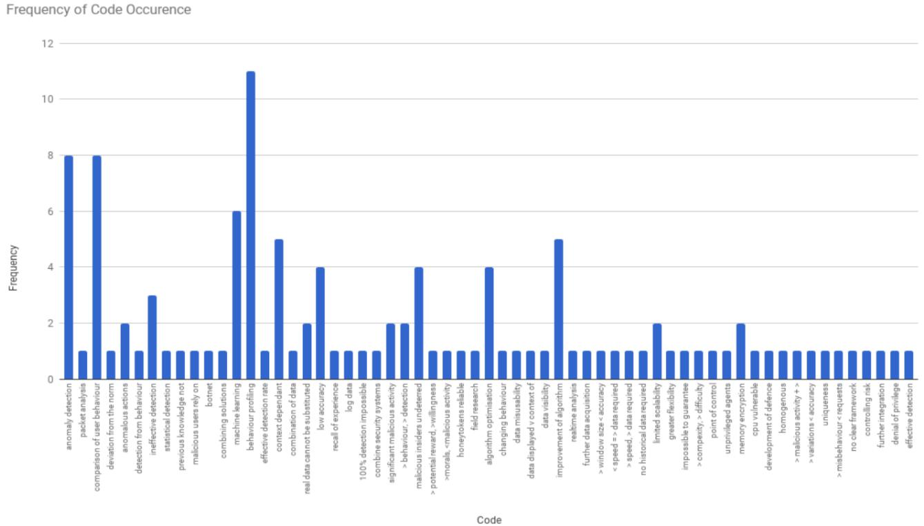

FIGURE 2. Frequency of code occurrence.

generated from reported results in individual studies, or their crudely aggregated results, could be used to assess study results against the theoretical ideal of TPR 1:0 and FPR 0:0. In this case, it was justi able to aggregate study results because not all studies report TPR and FPR together. Since study method and sample size are heterogeneous, it is not pos-sible to weight means together or analyse risk ratios or odds ratios for known in uential factors in each study. Thus meta-analysis is not feasible nor is a weighted average TPR and FPR in respect of each study since this would completely lose the resolution of the data.

The crudely aggregated grand mean was taken from mean values of the lowest TPR/FPR and the highest TPR/FPR reported in each study. Some studies did not provide detailed data but instead an author-calculated mean TPR/FPR. Thus, it was reasonable to aggregate all mean TPR/FPR values. Mean lowest and highest reported TPR/FPR values were used to construct an aggregated ROC curve in respect of 13/18 studies included in the systematic review. It should be borne in mind that quantitative non-inclusivity is 27:78% in respect of resultant values. This is, however, mitigated by qualitative analysis.

The aggregated grand mean was TPR 0:75 and FPR 0:32. Euclidean distance from the ideal is 0:25 for aggregated mean TPR and 0:32 for aggregated mean FPR, which is numerically signi cant. Mean lowest reported TPR and FPR were 0:57 and 0:17 respectively. Highest reported TPR and FPR were 0:84 and 0:36 respectively. The mean range for

FIGURE 3. ROC curve for mean and ideal values of FPR and TPR.
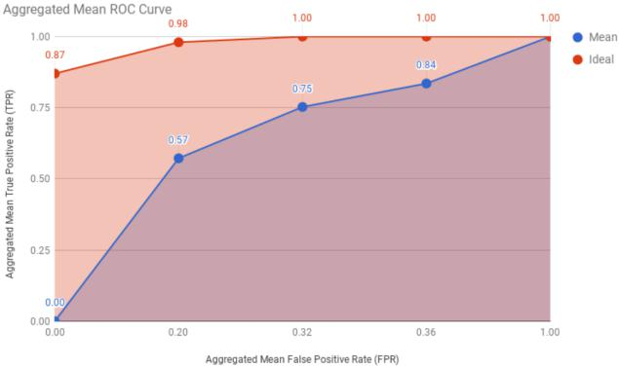

reported TPR and FPR values were 0:31 and 0:17 respec-

tively. Variances among mean TPR and FPR were 0:06

and 0:13 respectively. Standard deviations among mean

reported TPR and FPR were 0:24 and 0:36 respectively. The detailed TPR and FPR values for each study are listed

in Table 3. The ROC curve for ideal and actual grand mean values are presented in Fig. 3. It is notable that actual results are markedly below the theoretical ideal in the ROC graph.

IV. DISCUSSION

The signi cance of an inside threat was much dependent on the context in which the user acts maliciously. Both studies conclude, on the basis of apparently sound ndings, that

VOLUME 6, 2018 | 25171

S. Walker-Roberts et al.: Systematic Review of the Availability and Efficacy of Countermeasures to Internal Threats

TABLE 3. TPR and FPR values for included studies.

context was extremely subjective and thus it was impossible to adjust detection systems to be more or less sensitive to a particular context-based indicator. Both studies identify that the future research direction should be focussed towards discriminating context, perhaps by combining multiple IDPS technologies together to narrow the subjectivity of malicious contexts.

Both of these studies had a moderately high FPR and so the quantitative data reported in each study tends to sup-port, rather than contradict, the qualitative data extracted from those studies. [13], which proposes the high impact SNAD algorithm, identi es that the algorithm struggles to identify malicious activity where expected user behaviour is extremely homogeneous. In support of the above studies, it nds that a future research direction will inevitably be to develop semantic models of user behaviour in order to underline context in malicious activity in insiders.

A. PROFILING

Pro ling also features strongly within the literature at 21:8% occurrence within thematic analysis. Of 18 studies, 11 high-lighted pro ling as an important element. This con rms that roughly 2/3 of the studies included in the systematic review use historic behavioural data to examine anomalies poten-tially disclosing an inside threat.

The TPR values among methods using historic pro ling are higher as are FPR values, when compared to non-pro ling methods of IDPS. Non-pro ling methods of IDPS appear to identify a numerically signi cant lower reported value of TPR and FPR. It is dif cult to explain with precision the reason for this, but it is likely on the evidence available within the systematic review that this is accounted for by the fact that an IDPS which holds no historic data can not be prejudiced by historic data so as to exclude it at some future time.

A possible attack surface of pro le-based IDPS technolo-gies is that a malicious insider is either able to skew the historic pro le to repudiate their activity or they are able to normalise malicious activity. Whilst non-pro ling IDPS technologies report a lower TPR and FPR, they are not vulnerable to this phenomenon. A number of studies within the systematic review such as [14] identify that improved signature generation is an area of future works for this reason.

25172

B. ACCURACY

Accuracy features moderately as a theme within the literature with an occurrence at 10:3%.

It is a major problem within IDPS systems. In thematic analysis, 9 codes were related to serious accuracy problems within IDPS systems. The most inaccurate were the alarm-based anomaly detection system investigated by [15], with less than a 20% detection rate, and the RADISH system in [16] with a 50% detection rate. The rates of detection do not represent a poor study outcome or indeed a poor study (this would have been a publication bias), however it does present the need for signi cant further investigation.

Of the 12 studies the reported TPR and FPR values, it is apparent that their aggregated values fall signi cantly below the ideal ROC curve in Fig. 3. Given the context of the systematic review in investigating internal threats, this feature is important because as had already been described, one malicious activity is enough to be catastrophic.

The inability of any study to reliably prove a 100% TPR suggests that IDPS is not generally designed to prevent the types of inside malicious activity that are resulting in major data breaches. The tabulated range of the TPR and FPR values reported in studies appears to con rm the same problem.

C. SCALABILITY

The theme of scalability was moderately emergent within included studies at 13:8%. Studies included in the system-atic review reported a mixture of scalability issues. These included the need for greater exibility in scaling up detection resources, issues with the exibility of revocation of access and the ability of IDPS systems to cope with much larger volumes of data for analysis.

References [13] and [17] particularly highlight that when IDPS systems are scaled, naturally their TPR and FPR rates are adjusted, often because of increased inaccuracy at higher volumes. References [16] and [18] suggest that the only real way of addressing scalability issues is by combining multiple security methods to mitigate the effect of scalability. How-ever, those studies do stop short of testing this approach and identify this as an area of future work, thus it is not possible to conclude with any level of precision whether taking that modi ed approach would be effective.

VOLUME 6, 2018

S. Walker-Roberts et al.: Systematic Review of the Availability and Efficacy of Countermeasures to Internal Threats

In particular, the scalability issues identi ed in the lit-erature create concerns where big data and cloud services are concerned. If an IDPS can not be scaled up, then it is reasonable to question whether it can mitigate threats in a complex distributed computer system where system activity may exponentially increase over time. Despite this, there does not appear to be any data within these studies to prove that there would de nitely be a scalability problem in respect of each approach taken.

D. MACHINE LEARNING

Machine learning features less within the literature at a 6:9% theme occurrence. This is still signi cant. From the studies included in the systematic review, it is reasonable to conclude that machine learning in IDPS is an emerging academic inter-est. Studies take a mixed approach to application of machine learning in IDPS systems.

Reference [19] appears to be the earliest article of all studies included, which uses petri nets to classify whether user activities are taking place in an acceptable order. Con-versely, [20] uses nite state machines to create a fuzzy model of malicious activity which can then be subject to binary decisions based on set threshold. References [13] and [21] are studies which also apply inductive machine learning models to determine the de nition of anomalous behaviour. Other studies use k-nn and k-decision tree machine learning algo-rithms, such as in the RADISH system [16].

It is highly notable that in every study except SNAD [13], the detection rate is extremely high, with high values of TPR and low values of FPR. The TPR and FPR values are quite close to ideal, with a low Euclidean distance in respect of the same. Though this is observed, of 5 studies using machine learning, only two use real-world data to test the machine learning algorithms posed. It is therefore not possible to conclude with any degree of precision how well machine-learning based IDPS would tolerate real world malicious insider activity.

E. MALICIOUS INSIDERS UNDETERRED

The theme of malicious users being undeterred represents a small but statistically signi cant occurrence at 4:6%.
In quantitative studies, particularly [22], it was proven statistically that even though users said they would act dif-ferently in the knowledge of honeytokens, those that did know about the honeytokens were not at all deterred. There are serious drawbacks with the approach taken in this study because whilst the study was controlled and participants blinded, as the study points out employees who could face disciplinary action and potentially prosecution would treat the situation differently to students who know the exercise is a simulation.

In the MITRE trade secrets study, [23], employees reported that they would react differently if they were aware that their malicious behaviour was intercepted. Regrettably, this study does not test these results further and so it is not possible to fully compare this study with [22]. It is noteworthy that

VOLUME 6, 2018

only 4/173 malicious actors were deterred in [22], in the MITRE study users took signi cant evasive action to hide their malicious activities. The issue likely to identify with these studies is that a malicious insider in the real world may behave very differently and so only limited weight can be given to the information conveyed in these studies.

F. IMPROVEMENT OF ALGORITHM

Improvement of algorithm features as an important theme among included studies with an occurrence of 10:3%. Of 18 studies included in the systematic review, 5 ([21], [22], [14], [24], [25]) identi ed discrimination of malicious inside threats and the need for less intervention by an administrator as areas for signi cant improvement. Since the study data does not explicitly relate to these conclusions, it is not possible to conclude with certainty whether the authors in these studies took an accurate position. However, it appears on the basis of aggregated TPR and FPR values that these conclusions may be true of all included studies.

If all included studies require improvement in the same manner, this could explain the difference between the ROC curves in Fig. 3. It could provide substantiation to the idea that IDPS is not designed to deal with novel inside threats.

G. CONTROLLING RISK

The theme of controlling risk features as a small but statisti-cally signi cant occurrence at 5:7%.

References [21] and [26] both suggest and propose that risk can be controlled using a risk-reward approach. When a user does a malicious act their trust rating is downgraded until access is entirely denied. When a user engages in normal use, their trust rating is restored.

This approach is useful, but because it is longitudinal it may take time to detect malicious activities. It only takes a single malicious activity to be catastrophic. In addition, a malicious user may abuse the disposition of risk analysis by normalising their behaviour as they engage in malicious activities to repudiate their malicious acts. This is a serious drawback with risk analysis alone. Another manner of con-trolling trust is described in [27], but in the context of such a dangerous exploit could be the only real solution.

It is important that of all 18 studies included, there is little consideration of controlling risk which one could rightfully conclude would be important since the majority of studies con rm that a serious drawback in every case is an inability to detect 100% of malicious activity and mitigate it. Clearly risk control is an area where signi cant future research is required.

- COUNTERMEASURES TO COMBAT GROWING NUMBERS OF CRITICAL INFRASTRUCTURE SECURITY BREACHES
It is submitted that the source of the ‘‘straw that broke the camel’s back’’ security breaches is not within necessarily unapproved security practices or software failures. This sys-tematic review highlights that the issue is much more serious.

25173

S. Walker-Roberts et al.: Systematic Review of the Availability and Efficacy of Countermeasures to Internal Threats

The existing security technologies most commonly deployed today require statistical induction and are often heuristic in the absence of ‘‘experiential knowledge’’ of a potential threat. Thus, it is suggested that the only real mitigation is a complete redesign of computer infrastructures to not only make all resources immutable, but to remove the ability of an attacker to navigate resources across different infrastructure layers. This, it is submitted, is the only way of preventing compromise in a threat climate where a single system event can lead to catastrophic outcomes.

It is recommended that because the majority of security measures can not by themselves mitigate a catastrophic inside threat to a security system, multiple security measures must be used together to moderate otherwise substantial risk of catastrophe.

The US Department of Health and Human Resources that identi es in the OCR Breach Report that the majority of incidents were data disclosure incidents, mostly operator error, or were internal attacks that remained undetected for a signi cant period of time resulting in loss and damage [28].

It appears from the literature that the best approach to be taken is to incapacitate a malicious insider by removing data visibility and locking out permissions entirely so that internal privilege can not be abused. In an increased threat climate which the literature suggests cannot be entirely mitigated, it is extremely important that system administrators do not rely on the automation some technologies provide and remain alert to unusual activity that may not be automatically alerted to them. System and software design should take into account the need to mitigate the risk of an internal threat starting at the very lowest level.

The literature body generally as included within this sys-tematic review takes a common focus towards IDPS with few studies focussing on other ways of mitigating insider threats. This represents a de ciency in the scope of active research in the elds of computer science and computer security.

Taken together, all studies con rm that 100% detection of malicious insider threats are not possible and that to some extent, malicious insiders are not deterred by in-place secu-rity measures. This is a very important feature within the literature.

In recent years, it is apparent that there is an increasing trend within the literature towards predictive behavioural modelling to identify early malicious activity before a catas-trophic data breach, though it will be clear that these behavioural systems take time to work and are therefore inappropriate in dealing with zero day or other novel inside threats.

It is important to note that the literature consensus appears to be that ‘‘malicious insider’’ and ‘‘inside threat’’ are very poorly de ned and are applied loosely to mean a person, whereas in practice an insider could be an outsider with privileged internal access to a computer system.

Machine learning in recent years has become highly promi-nent within the literature, accounting for a large number of included studies. These studies have the highest levels of

25174

accuracy in terms of TPR and FPR. However, the majority of machine learning studies failed to test real-world datasets.

Accuracy features prominently in all included studies, with those testing real-world data appearing to perform the most poorly. The reason for this is not particularly clear but may be because of optimistic modelling. On the whole it is clear that no reported technique within the included literature base can mitigate 100% of inside threats, and thus cannot prevent a prospective single fatal breach.

The majority of studies identify that proposed algo-rithms need signi cant algorithm optimisation by way of improved signature generation, improved moderation of risk and improved scalability. In totality, the literature suggests that there is no way to mitigate ‘‘knockout’’ data breaches which could effectively destroy an organisation, cause serious data loss or pose a signi cant threat to personal safety as a result of a sabotage of critical infrastructure. This is notable.

Theoretically, it appears that the only way to entirely mit-igate an inside threat is to entirely remove privilege. It is possible that by controlling the degrees of freedom associated with speci c permissions and data visibility, a malicious insider can be ‘‘sandboxed’’.

It may be possible to develop a model based upon the degrees of freedom of a computing resource and a potential malicious insider. The present literature base as included within this systematic review suggests that the approach that needs to be taken is to treat all users as a threat purely because it may not be possible to identify a malicious insider until it is too late.

VI. CONCLUSION AND FUTURE WORK

This systematic review was limited in that meta-analysis was not possible due to heterogeneity across studies. This is a very important remark because the resulting issue was that quantitative data could only be synthesised within 72:22% inclusivity. There is therefore substantial risk that quantitative data may have been abstracted.

Whilst a qualitative methodology was applied for exactly that reason, qualitative data may not have made up for the absence of quantitative data which provides a temporal dimension to the data. Due to the need for study synthesis to be solidly founded on very reliable data and methodology in order for qualitative analysis to be useful, only 18 studies could be used due to issues surrounding quality and the lack of quantitative data which was reliable and relevant. This may have excluded a large number of potentially relevant studies in a potentially less stringent protocol. Too many studies focussed on performance not reliability.

The role of negligent insiders in critical healthcare infras-tructure is only becoming more apparent. Thus, the need for improved technology needs to be balanced against the need for user education and policy centred around the user that exposes critical healthcare infrastructure to catastrophe.

Signi cant work needs to be undertaken to create more effective IDPS techniques. Further work also needs to be undertaken to create a model of threat mitigation which takes

VOLUME 6, 2018

S. Walker-Roberts et al.: Systematic Review of the Availability and Efficacy of Countermeasures to Internal Threats

TABLE 4. Systematic review protocol.


VOLUME 6, 2018 | 25175

S. Walker-Roberts et al.: Systematic Review of the Availability and Efficacy of Countermeasures to Internal Threats

TABLE 4. (Continued.) Systematic review protocol.
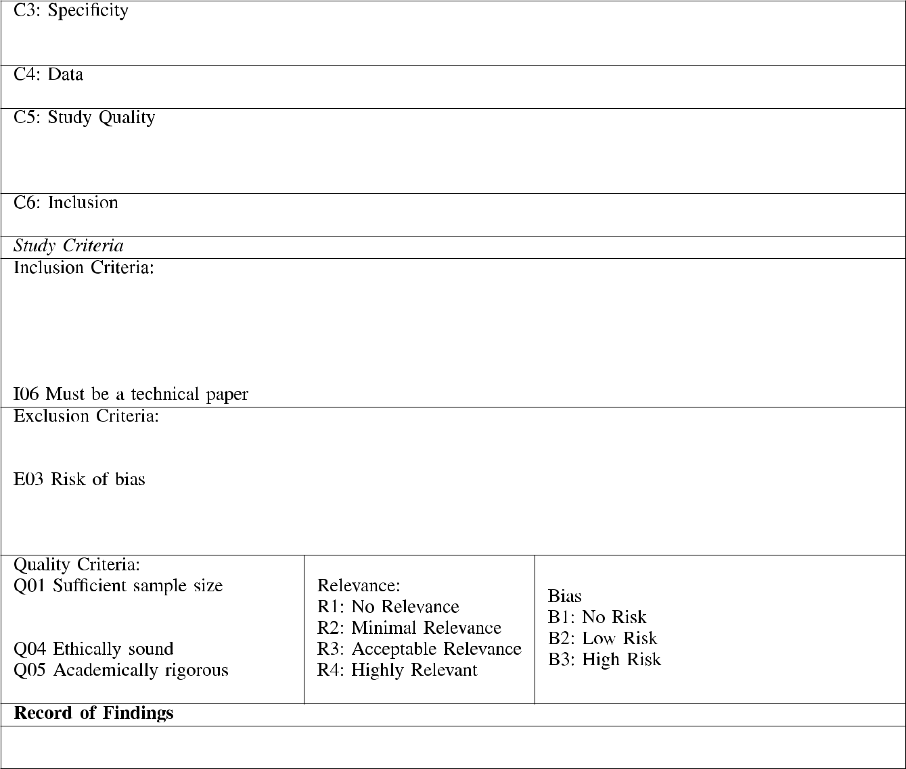

into account the unknown malicious insider whom only need commit himself to one activity for it to be catastrophic. Additional work also needs to be undertaken to understand the nature of inside threats so that new technologies can be developed around potential further ndings.

APPENDIX

See Table 4.

REFERENCES

- Verizon RISK. (Oct. 2017). VCDB/Yearly.Png at Master vz-Risk/VCDB. Accessed: Nov. 2, 2017. [Online]. Available: https://github.com/vz-risk/ VCDB/blob/master/ gure/yearly.png

- S. Broderick, ‘‘Firewalls Are they enough protection for current net-works?’’ Inf. Secur. Tech. Rep., vol. 10, no. 4, pp. 204 212, Jan. 2005. [Online]. Available: http://dx.doi.org/10.1016/j.istr.2005.10.002
- Verizon RISK. (Oct. 2017). vz-Risk/VCDB: Veris Community Database.

Accessed: Oct. 26, 2017. [Online]. Available: https://github.com/vz-risk/

VCDB

25176

- National Audit Of ce. (Oct. 2017). Investigation: Wannacry Cyber Attack

and the NHS (Summary). Accessed: Feb. 7, 2018. [Online]. Available: https://www.nao.org.uk/wpcontent/uploads/2017/10/Investigation-WannaCry-cyber-attack-andthe-NHS-Summary.pdf

- Sans Institute. (2014). New Threats Drive Improved Practices: State of

Cybersecurity in Health Care Organizations. Accessed: Feb. 7, 2018.

[Online]. Available: https://www.sans.org/readingroom/whitepapers/ analyst/threats-drive-improved-practices-statecybersecurity-health-care-organizations-35652

- Accenture. (2015). The $300 Billion Attack Accenture. Accessed: Feb. 7, 2018. [Online]. Available: https://www.accenture.com/ t20171221T005341Z

- I. A. Gheyas and A. E. Abdallah, ‘‘Detection and prediction of insider threats to cyber security: A systematic literature review and meta-analysis,’’ Big Data Anal., vol. 1, p. 6, Aug. 2016. [Online]. Available: https://doi.org/10.1186/Fs41044-016-0006-0

- S. Walker-Roberts. (Oct. 2017). Systematic Literature Search. Accessed: Nov. 3, 2017. [Online]. Available: https://drive.google.com/open?id= 1b0YA6AJ5waHkCkp2UGAlP15 LTbyC8cori4Mw pKyA4

- K. Hannes, C. Lockwood, and A. Pearson, ‘‘A comparative analysis of three online appraisal instruments’ ability to assess validity in qualitative research,’’ Qualitative Health Res., vol. 20, no. 12, pp. 1736 1743, 2010.

VOLUME 6, 2018

S. Walker-Roberts et al.: Systematic Review of the Availability and Efficacy of Countermeasures to Internal Threats

- Specialist Unit for Review Evidence. (Oct. 2017). Critical Appraisal Checklists Specialist Unit for Review Evidence Cardiff University. Accessed: Nov. 3, 2017. [Online]. Available: https://www.cardiff.ac.uk/specialist-unit-for-review-evidence/resources/ critical-appraisal-checklists

- Flinders University. (Oct. 2017). Aacods Checklist. Accessed: Nov. 3, 2017. [Online]. Available: https://dspace. inders.edu.au/jspui/ bitstream/2328/3326/4/AACODS_Checklist.pdf

- Joanna Briggs Institute. (Oct. 2017). JBI Reviewer’s Manual. Accessed: Nov. 3, 2017. [Online]. Available: https://reviewersmanual. joannabriggs.org/

- Y. Chen, S. Nyemba, W. Zhang, and B. Malin, ‘‘Specializing network analysis to detect anomalous insider actions,’’ Secur. Informat., vol. 1, p. 5, Dec. 2012. [Online]. Available: https://doi.org/10.1186/F2190-8532-1-5

- S. R. Hussain, A. M. Sallam, and E. Bertino, ‘‘DetAnom: Detecting anoma-lous database transactions by insiders,’’ in Proc. 5th ACM Conf. Data Appl. Secur. Privacy (CODASPY), 2015, pp. 25 35. [Online]. Available: https://doi.org/10.1145/F2699026.2699111

- P. M. Nasr and A. Y. Varjani, ‘‘Alarm based anomaly detection of insider attacks in SCADA system,’’ in Proc. Smart Grid Conf. (SGC), Dec. 2014, pp. 1 6. [Online]. Available: https://doi.org/10.1109/Fsgc.2014.7090881

- B. Böse, B. Avasarala, S. Tirthapura, Y.-Y. Chung, and D. Steiner, ‘‘Detecting insider threats using RADISH: A system for real-time anomaly detection in heterogeneous data streams,’’ IEEE Syst. J., vol. 11, no. 2, pp. 471 482, Jun. 2017. [Online]. Available: https://doi.org/10. 1109/Fjsyst.2016.2558507

- A. Liu, J. Chen, and L. Yang, ‘‘Real-time detection of covert channels in highly virtualized environments,’’ in Critical Infrastructure Protection V. Berlin, Germany: Springer, 2011, pp. 151 164.
- K. I. Santosa, C. Lim, and A. Erwin, ‘‘Analysis of educational institution DNS network traf c for insider threats,’’ in Proc. Int. Conf. Comput., Control, Informat. Appl. (IC3INA), Oct. 2016, pp. 147 152. [Online]. Available: https://doi.org/10.1109/Fic3ina.2016.7863040
- M. Chagarlamudi, B. Panda, and Y. Hu, ‘‘Insider threat in database sys-tems: Preventing malicious users’ activities in databases,’’ in Proc. 6th Int. Conf. Inf. Technol., New Generat., Apr. 2009, pp. 1616 1620. [Online]. Available: https://doi.org/10.1109/Fitng.2009.67
- Y. Yu. (2011). Anomaly Intrusion Detection Based Upon an Arti-cial Immunity Model. [Online]. Available: https://doi.org/10.1145/ F2016039.2016075

- M. Gafny, A. Shabtai, L. Rokach, and Y. Elovici, ‘‘Detecting data mis-use by applying context-based data linkage,’’ in Proc. ACM Workshop Insider Threats-Insider Threats, 2010, pp. 3 12. [Online]. Available: https://doi.org/10.1145/F1866886.1866890

- A. Shabtai, M. Bercovitch, L. Rokach, Y. Gal, Y. Elovici, and E. Shmueli, ‘‘Behavioral study of users when interacting with active honeytokens,’’ ACM Trans. Inf. Syst. Secur., vol. 18, no. 3, Feb. 2016, Art. no. 9. [Online]. Available: https://doi.org/10.1145/F2854152
- D. Caputo, M. Maloof, and G. Stephens, ‘‘Detecting insider theft of trade secrets,’’ IEEE Security Privacy, vol. 7, no. 6, pp. 14 21, Nov. 2009. [Online]. Available: https://doi.org/10.1109/Fmsp.2009.110

- G. Alotibi, N. Clarke, F. Li, and S. Furnell, ‘‘User pro ling from net-work traf c via novel application-level interactions,’’ in Proc. 11th Int. Conf. Internet Technol. Secured Trans. (ICITST), Dec. 2016, pp. 279 285. [Online]. Available: https://doi.org/10.1109/Ficitst.2016.7856712
- R. Mohan, V. Vaidehi, A. K. A, M. M, and S. S. Chakkaravarthy, ‘‘Complex event processing based hybrid intrusion detection system,’’ in Proc. 3rd Int. Conf. Signal Process., Commun. Netw. (ICSCN), Mar. 2015, pp. 1 6. [Online]. Available: https://doi.org/10.1109/Ficscn.2015.7219827

VOLUME 6, 2018

- N. Baracaldo and J. Joshi, ‘‘A trust-and-risk aware RBAC framework: Tackling insider threat,’’ in Proc. 17th ACM Symp. Access Control Models Technol. (SACMAT), 2012, pp. 167 176. [Online]. Available: https://doi.org/10.1145/F2295136.2295168

- B. Hopkins, J. Shield, and C. North, ‘‘Redirecting DRAM memory pages: Examining the threat of system memory hardware trojans,’’ in Proc. IEEE Int. Symp. Hardw. Oriented Secur. Trust (HOST), May 2016, pp. 197 202. [Online]. Available: https://doi.org/10.1109/Fhst.2016.7495582

- U.S. Department of Health and Human Services. (2018). Ocr Breach Report. Accessed: Feb. 7, 2018. [Online]. Available: https://ocrportal. hhs.gov/ocr/breach/breach report.jsf

STEVEN WALKER-ROBERTS is currently an Honorary Research Fellow and a Sessional Lec-turer with Manchester Metropolitan University. He is also an Academic Lawyer. He is also a Public Policy Adviser to the U.K. Government, having made signi cant contributions to home affairs and the criminal law. His research interests include national security, statecraft, and zero trust secu-rity. Other interests include technology law and the practical implementations of zero trust security

systems to mitigate complex security threats.


MOHAMMAD HAMMOUDEH is currently the Head of the MMU IoT Laboratory and a Senior Lecturer in computer networks and security with the School of Computing, Math and Digital Technology, Manchester Metropolitan University. He has been a researcher and publisher in the eld of big sensory data mining and visualization. He is a highly pro cient, experienced, and profes-sionally certi ed cybersecurity professional, spe-cializing in threat analysis, and information and

network security management. His research interests include highly decen-tralized algorithms, communication, and cross-layered solutions to Internet of Things, and wireless sensor networks.


ALI DEHGHANTANHA (GS’07 M’12 SM’16) is currently a Senior Lecturer in cyber security with the University of Shef eld. His research inter-ests include the applications of arti cial intel-ligence and machine learning in cyber security with special focus on targeting advanced persistent threat actors. He is an EU Marie-Curie Fellow.

25177

